Milestones

Kurt Robinson

# Mid-Project Deliverable

## Due April 8th

This milestone involves producing a report of what progress we have made in the planning stages of this project. I chose to produce a Gantt chart so that we can decide on our milestones and list each task that we have to undertake during development so that we can keep track during this project. All members are required to produce different sections of this report as displayed in the table below.

Tools that we require in order to reach this milestone include are Microsoft Word, as no development is required yet since it is all documentation and Microsoft Project, for creating the GANTT chart. In this stage it is very simple.

|  |  |  |
| --- | --- | --- |
| Resources | Tasks | Duration in Days |
|  |  |  |
| Peter | SRS Document | 8 |
|  | Risk Management | 2 |
|  |  |  |
| Jamie | Feasibility Study | 9 |
|  | Code of Conduct | 1 |
|  |  |  |
| Kurt | Progress Reports | 8 |
|  | Milestones Document | 2 |
|  |  |  |
| Josh | Archive Map | 1 |
|  |  |  |
| James | Objectives | 2 |
|  |  |  |
| Josh, James | Detailed Project Plan | 8 |
| Josh, Peter | Visual Data Document | 1 |

# 

# Environment set up

## Due April 9th

Setting up our development environment includes preparing our MySQL database with our tables prepared to store the imported data. Website hosting also must be set up with necessary tools ready such as user profile creation and security. Our coding environment must be set up identically across each group members computers so that there will be less risk of file incompatibility that may arise when using different versions of software.

|  |  |  |
| --- | --- | --- |
| Resources | Tasks | Duration in Days |
|  |  |  |
| Josh | Set up MySQL Database | 2 |
|  |  |  |
| James | Set up coding environment | 2 |
|  |  |  |
| Peter | Set up website tools | 2 |

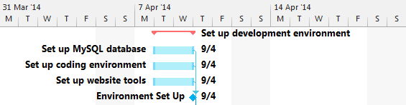

# Iteration 1.1 - Website Constructed

## Due April 17th

When development begins the iterations are split into two paths iterating at the same time (1.1, 1.2 and 2.1, 2.2) as they are not dependent of each other and have different resources assigned to those tasks.

The analysis and design tasks run simultaneously over a day. This is where research of website construction occurs and Peter begins to plan how development takes place. Once developed over multiple days Peter must then test all aspects of what he created and produce a test report then review the work he has done over the last week.

|  |  |  |
| --- | --- | --- |
| Resources | Tasks | Duration in Days |
|  |  |  |
| Peter | 1.1 Analysis | 1 |
|  | 1.1 Design | 1 |
|  | 1.1 Development | 4 |
|  | 1.1 Testing | 1 |
|  | 1.1 Review | 1 |

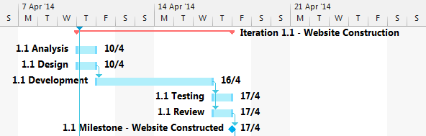

# Iteration 1.2 – User Management System

## Due April 23rd

This milestone is achieved through developing the user management system on the website. This means enabling a log in service for those accessing the program and giving users different permissions based on their position (such as Administrator, Project Manager, General User).

|  |  |  |
| --- | --- | --- |
| Resources | Tasks | Duration in Days |
|  |  |  |
| Peter | 1.2 Analysis | 1 |
|  | 1.2 Design | 1 |
|  | 1.2 Development | 5 |
|  | 1.2 Testing | 1 |
|  | 1.2 Review | 1 |

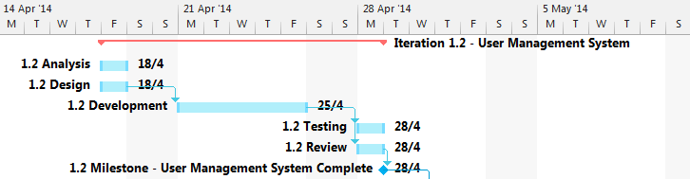

# Iteration 2.1 – Import Data

## Due April 21st

This milestone is achieved by successfully importing the data from the Python SVN page, bugs page and archive files supplied to us into files saved to the client’s computer.

|  |  |  |
| --- | --- | --- |
| Resources | Tasks | Duration in Days |
|  |  |  |
| Josh, Jamie | 2.1 Analysis | 2 |
|  | 2.1 Design | 2 |
|  | 2.1 Development | 4 |
|  | 2.1 Testing | 1 |
|  | 2.1 Review | 1 |
|  |  |  |
|  |  |  |

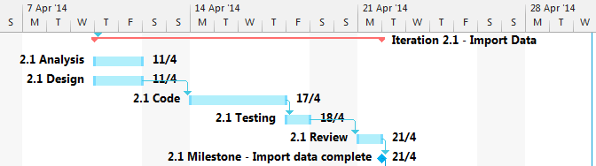

# Iteration 2.2 – Data Translation

## Due April 30th

This milestone is achieved through successfully translating the data imported in iteration 2.1 into data that can be stored within the MySQL database so that it can be accessed through the GUI to show visualisations and be able to be manipulated.

|  |  |  |
| --- | --- | --- |
| Resources | Tasks | Duration in Days |
|  |  |  |
| James, Kurt, Josh, Jamie | 2.2 Analysis | 2 |
|  | 2.2 Design | 2 |
|  | 2.2 Development | 3 |
|  | 2.2 Testing | 1 |
|  | 2.2 Review | 1 |

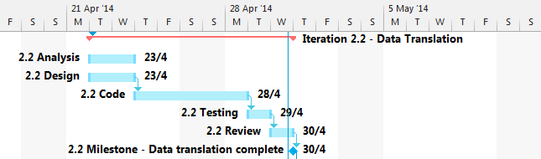

# Iteration 2.3 – Data Manipulation

## Due May 14th

Once we have our data translated and accessible from the database we can then begin to code the data manipulation module which should allow the user (who has the correct permission) to locate any data they wish from the database, edit its attributes, then save it.

|  |  |  |
| --- | --- | --- |
| Resources | Tasks | Duration in Days |
|  |  |  |
| James, Josh, Jamie | 2.3 Analysis | 2 |
|  | 2.3 Design | 2 |
|  | 2.3 Development | 5 |
|  | 2.3 Testing | 2 |
|  | 2.3 Review | 1 |

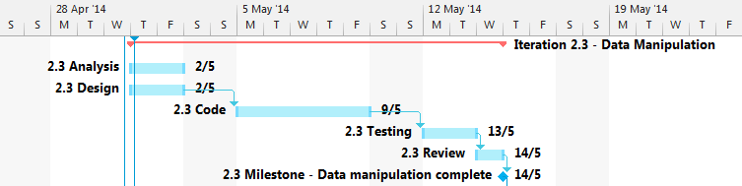

# Iteration 2.4 – Data Visualisation

## Due May 14th

This iteration runs concurrently with iteration 2.3 as they do not depend on each other. They both needed iteration 2.2 complete to access that data. This milestone is achieved by successfully using data stored in the database to convert into a visualisation such as a graph or other appropriate diagram.

|  |  |  |
| --- | --- | --- |
| Resources | Tasks | Duration in Days |
|  |  |  |
| Peter, Kurt | 2.4 Analysis | 2 |
|  | 2.4 Design | 3 |
|  | 2.4 Development | 5 |
|  | 2.4 Testing | 1 |
|  | 2.4 Review | 1 |

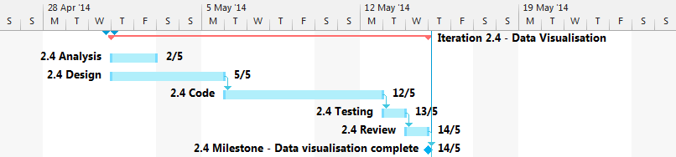

# Approval Testing with Client

## Due May 20th

This milestone is when we expect to have a fully functional program ready to use. As a part of deployment we plan to create a user manual to aid those who may need guidance in using this software. Once we sit down with our client and walk them through our product and receiving approval we will then be able to commence work on our final report.

|  |  |  |
| --- | --- | --- |
| Resources | Tasks | Duration in Days |
|  |  |  |
| Peter, Kurt | User Manual | 1 |
|  |  |  |
| James | Testing with Client | 1 |

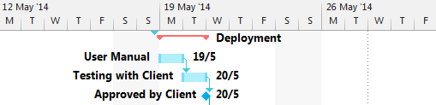

# Submit Final Report

## Due May 20th

Just with the first milestone of the mid-project delivery, this report requires Microsoft word in order to complete documentation. All members of the group are again taking part in this stage with tasks assigned to each.

Once we have completed each section of the final report we will go over it together to ensure that it is of substantial quality and is presented to the client in a well formatted manner.

|  |  |  |
| --- | --- | --- |
| Resources | Tasks | Duration in Days |
|  |  |  |
| Peter | Business Case  Meta-Report | 1  2 |
|  |  |  |
| Jamie | Test phase details, plans and cases | 2 |
| Kurt | UML Diagrams  Effort Estimation | 3  1 |
|  |  |  |
| Josh, James | Architecture Design | 3 |
|  |  |  |
| All Members | Quality Check Final Report | 1 |
|  |  |  |
|  |  |  |

